IMI PhD international mobility program 2025

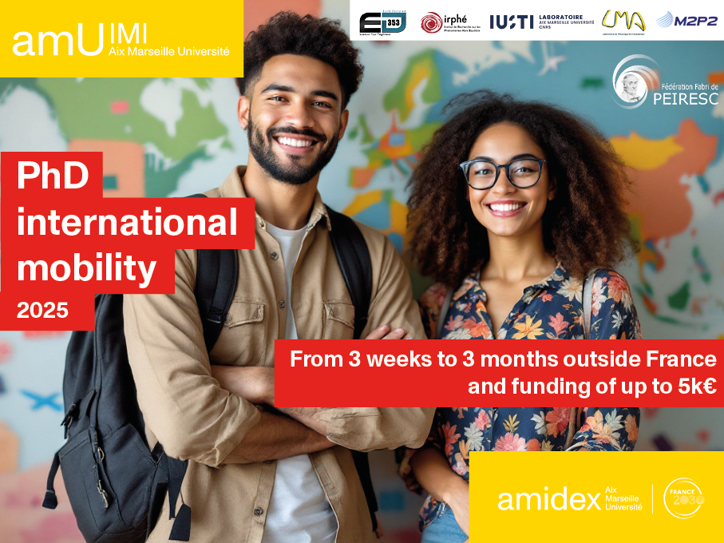

From 3 weeks to 3 months outside France and
funding of up to 5k€.

The Institute for Mechanical Engineering of Aix-Marseille University is launching its PhD international mobility program (Stays of between 3 weeks and 3 months outside France in a single period ). This is part of the PhD program supported by the Institute, and co-accredited by the doctoral school for engineering sciences ED353 which aims at strengthening education through research, developing student disciplinary and interdisciplinary skills and knowledge, and internationalizing student education cursus.

- Motivations :

- Learn a new technique;
- Deepen your doctoral subject or open up to a slightly different (but somewhat related) subject in another laboratory;
- Start a collaboration;
- Get the label “Doctorat Européen ¹”;
- Learn how to write a proposal including a technical/scientific description of the project, motivation, scheduling, and budgeting, as well as a feedback report after the mobility and thus develop an useful soft skills in writing a proposal.

All PhD students of the Institute can apply to this call provided the agreement of the PhD employer, PhD supervisor and host institution in the foreign country. The PhD contract must not end within the mobility period. The Institute will fund up to 5k€ and while co-financing is not mandatory it could be a plus. Mobility within the CIVIS European Campus is also strongly encouraged
( https://civis.eu/fr).

Projects can be submitted “au fil de l’eau” to imi-contact@univ-amu.fr following the provided template. They will be evaluated by the scientific board of IMI and the results of the evaluation will be announced within one month after the submission of the project.

IMI team

➔Form to be sent before to: cedric.fages@univ-amu.fr
Mobility Project Title:
Principal Investigator:
- First name:
- Last name:
- Phone:
- Email:
- Doctoral School:
- Specialization:
- PhD start date:
- PhD funding source (Doctoral School, ANR, contract, etc.):
PhD Topic:
AMU Laboratory involved in thesis supervision/co-supervision:
☐ IRPHE ☐ LMA ☐ IUSTI ☐ M2P2
Supervisors and Co-Supervisors:
- Name, laboratory, institution
Supervisors’ assessment (max. 10 lines)
(Signature required)
Collaborative context:
☐ No ☐ Yes (please specify)
Mobility period envisaged:

Host Laboratory Contact Person:
- First name, surname
- Email
- Position
- Laboratory
- University/institution
- Country
- Address
Contact person’s assessment (max. 10 lines)
(Signature required)

Scientific Project (max. 4 pages, font size 12)

1. Summary (½ page max.)
Concise overview of the project.
2. Background, Motivation, Objectives, and Scientific Description (max. 2 pages)
- Context and state of the art
- Motivation and objectives
- Relevance of the chosen host team
3. Risk Management and Contingency Plan (½ page max.)
Identification of potential risks and proposed mitigation strategies.
4. Impact (½ page max.)
- On PhD research and scientific knowledge
- On personal and professional development
- On scientific advancement

5. Timeline/Planning (½ page max.)
Expected schedule (a Gantt chart may be included).
6. Budget and Justification (½ page max.)
- Eligible costs: travel, accommodation, meals (max. €40/day).
- Co-funding details if applicable.
- For budget questions, contact IMI directly.
7. Expense Tracking During Mobility
During the mobility period abroad, the PhD student is required to maintain an updated expense log and keep all receipts.

Obligatory publication and communication rules

If the mobility project is granted, the PhD student agrees to comply with IMI and AMIDEX publication rules for any publication or communication related to the project.
1. Oral and poster communications and websites must display the AMU and "Investissements d'Avenir" logos:
- France 2030 : https://amubox.univ-amu.fr/s/M2SynDxqkty8dmG
- AMU, A*Midex, IMI : https://amubox.univ-amu.fr/s/SyxWcEwypWkxE8F?path=%2F
2. Publications from the institute will bear the mention:
- "The project leading to this publication has received funding from the Excellence Initiative of Aix-Marseille University - A*Midex, a French "Investissements d'Avenir programme" AMX-19-IET-013".

3. Publications must be deposited in HAL AMU, the University's open archive, in the A*Midex collection:
- For these, the full text of the final version accepted by the publisher is required.
- To access HAL AMU/A*Midex : https://hal.archives-ouvertes.fr/AMIDEX.

Obligatory commitments

If the mobility project is granted, the PhD student agrees to provide a short report (2 pages max.) on the work carried out during the mobility. This short report will be required before any reimbursement of expenses.
A short testimony of 1000 caracters (including spaces) describing the mobility experience, with a minimum of 3 pictures in high resolution (including a portrait) ; Or a short movie (one minute max.).
Name and signature:

